2019
TNG

APD

[Spirits]
An Investigation Into Demonic Possession And The Connections To Alcohol



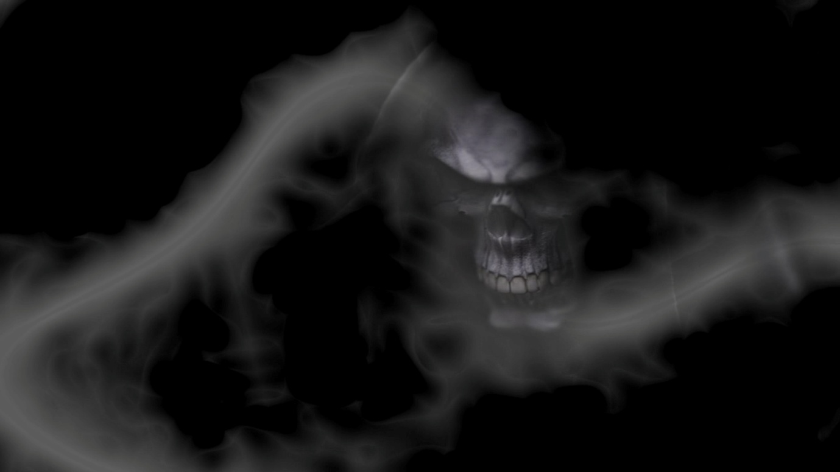
Contents

Introduction - A Spiritual Battle 3

Part One - Studies And Reports On Alcohol Use 7

Part Two - Prohibition 13
Part Three - What is Schizophrenia? 15

Part Four - Demonic Possession 17

Part Five - What Is Going On Here? 21

Part Six - The Origin Of Alcohol 22

Part Seven - Another Piece Of The Puzzle, Not Just American Gods 23

Part Eight - My Testimony 25

Part Nine - "9" 32

Part Ten - They Tell You In The Movies 34

Part Eleven - Grounding & The Power Of A Soul 36

tl;dr 37

Addendum 39

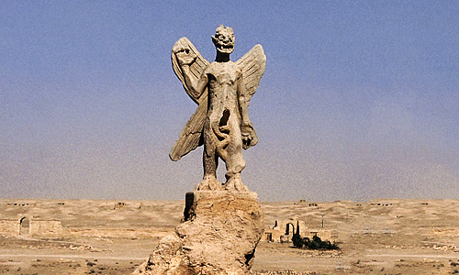
Introduction
A Spiritual Battle?

Sometimes there are thoughts that are best kept locked away in a corner of the mind, shut away from the conscious as they are so dark and grim that if explored they may lead to realisations that are beyond comprehensible. But can we leave these thoughts without facing the consequences. Left to collect dust and fester, how do we know that these do not affect our conscious mind?

Here then is an investigation into my true fear of what maybe going on in this realm, one that I have put off for so long, yet has bubbled up from the deepest place in my mind time and again. I have already connected the dots, now I present to you a possible explanation for the madness we see in this reality on a daily basis.

I will let you into a little secret of mine. Many people scoff and laugh at the mention of mediums and psychics. I did too when I was growing up. My head was chock full of science and programming, my first wife used to go for readings and some of the tape recordings of the sessions she came back home with were compelling to say the least, I in the main ignored this subject. But after the turn of the Millennium I found myself actually receiving training to become a medium and I was talented to say the least, where it took me shocked me to the core of my soul. But it did lead me to know that I truly had a soul and that I was not an empty vessel. I have never used this training for profit or gain, in fact this part of my life I shut out as it so deeply affected me and does to this day.

Like many of the other revelations discovered on a daily basis at JLB.com the material I present here maybe hard to swallow on first appearance. But bear with me I am going to take you on a roller coaster ride into implications that enter the depths of hell but in the end rise up to twin towers of illumination.

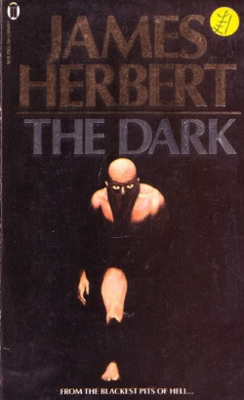The darkness beckons.

The Definitions Of Spirit

spirit
NOUN
spirits (plural noun)
  - the non-physical part of a person which is the seat of emotions and character; the soul.
"we seek a harmony between body and spirit"
synonyms:
soul · psyche · inner self · inner being · essential being · pneuma .

anima · ego · id · ka · atman
antonyms:
body · flesh
    - the non-physical part of a person regarded as their true self and as capable of surviving physical death or separation.
"a year after he left, his spirit is still present"
synonyms:
life force · animating principle · vital spark · breath of life · élan vital
    - the non-physical part of a person manifested as an apparition after their death; a ghost.
"a priest performed a rite of exorcism and the wandering spirit was ousted"
synonyms:
ghost · phantom · spectre · apparition · wraith · shadow ·

presence · bodach · Doppelgänger · duppy · spook · phantasm · shade · revenant · visitant · wight · eidolon · manes
    - a supernatural being.
"shrines to nature spirits"
    - (Spirit)
short for Holy Spirit.
  - the prevailing or typical quality, mood, or attitude of a person, group, or period of time.
"I hope the team will build on this spirit of confidence" ·

"the university is a symbol of the nation's egalitarian spirit"
synonyms:
ethos · prevailing tendency · motivating force · animating principle ·

dominating characteristic · essence · quintessence · atmosphere · mood · feeling · temper · tenor · climate · attitudes · beliefs · principles · standards · ethics
    - a person identified with their most prominent quality or with their role in a group or movement.
"he was a leading spirit in the conference"
    - (spirits)
a person's mood or attitude.
"the warm weather lifted everyone's spirits" ·

"he confessed in a spirit of self-respect"
synonyms:
mood · frame of mind · state of mind · emotional state · humour .

temper · temperament · disposition · character · nature · personality · temper · make-up · humour · cast/turn of mind · complexion · mind · heart · attitude · frame of mind · way of thinking · way of looking at it · state of mind · point of view · outlook · thoughts · ideas
    - the quality of courage, energy, and determination.
"his visitors admired his spirit and good temper"
synonyms:
morale · team spirit · esprit de corps · courage · bravery ·

courageousness · braveness · pluck · pluckiness · valour · strength of character · fortitude · backbone · spine · mettle · stout-heartedness · determination · firmness of purpose · resolution · resoluteness · resolve · fight · gameness · guts · grit · spunk · bottle · sand · moxie · animation · enthusiasm · eagerness · keenness · liveliness · vivacity · vivaciousness · energy · verve · vigour · dynamism · zest · dash · elan · panache · sparkle · exuberance · gusto · brio · pep · go · sap · fervour · zeal · fire · passion · pizzazz · oomph · zing · zip · zap · vim · get-up-and-go
    - the real meaning or the intention behind something as opposed to its strict verbal interpretation.
"the rule had been broken in spirit if not in letter"
synonyms:
real/true meaning · true intention · essence · substance
  - BRITISH
(spirits)
strong distilled alcoholic drink such as brandy, whisky, gin, or rum.
synonyms:
strong liquor · liquor · strong drink · gin · vodka · whisky · brandy · rum ·

hard stuff · shorts · firewater · hooch
    - a volatile liquid, especially a fuel, prepared by distillation.
"aviation spirit"
    - archaic
a solution of volatile components extracted from something, typically by distillation or by solution in alcohol.
"spirits of turpentine"
  - archaic
a highly refined substance or fluid thought to govern vital phenomena.
VERB
spirits (third person present)
  - convey rapidly and secretly.
"stolen cows were spirited away some distance to prevent detection"
synonyms:
abduct · kidnap · make off with · run away with · whisk away · carry off ·

steal away with · snatch · seize · abscond with
Origin
Middle English: from Anglo-Norman French, from Latin spiritus ‘breath, spirit’, from spirare ‘breathe’.

Is it not strange that one word can have so many definitions and inferences, I am sure there are other words in the English language that do in fact equal or exceed "spirit" for the amount of definitions, but in this particular case it is no coincidence.
Definition number 4 "a highly refined substance or fluid thought to govern vital phenomena" is a link between the other definitions and will be very pertinent going forward in this article.

A link below to a brief description of spirit alcohol.
https://vinepair.com/spirits-101/what-are-spirits/

Part One - Studies And Reports On Alcohol Use
The Shining is a horror movie. The film is based on Stephen King's 1977 novel The Shining.
The movie is about Jack Torrance (Jack Nicholson), an aspiring writer and recovering alcoholic who takes his wife and son to a hotel to keep him company throughout the long and isolated nights. During their stay strange things occur when Jack's son Danny sees gruesome images powered by a force called "The Shining" and Jack is heavily affected. Along with writer's block and the demons of the hotel haunting him. Jack has a complete mental breakdown and the situation takes a sinister turn for the worse.
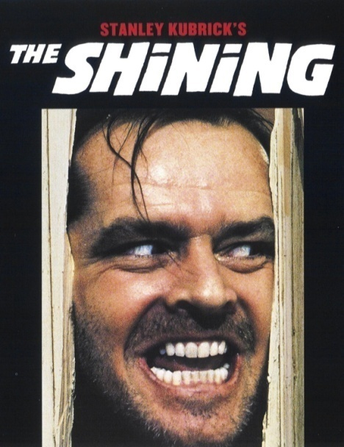
Stanley Kubrick, 1980

Alcohol Poisoning & Propaganda In The Media
"According to a survey in England, approximately 35,000 to 40,000 people were admitted to the hospitals because of acute alcohol poisoning every year. Over 1 million people around the world, died in 2016 because of alcohol poisoning. There are over 3 million people that are taking psychological therapies from psychologists because of alcohol poisoning. Alcohol poisoning makes your body work slow over the time and takes you to the last stage of your life. There are no effective medications found to treat it."
Taken from the article linked below.
https://healthaio.com/alcohol-poisoning-treatments/

Time to have a look at some of these studies that the so called "experts" cite and more.
Alcohol Poisoning Deaths — United States, 2010–2012
Results: During 2010–2012, an annual average of 2,221 alcohol poisoning deaths (8.8 deaths per 1 million population) occurred among persons aged ≥15 years in the United States. Of those deaths, 1,681 (75.7%) involved adults aged 35–64 years, and 1,696 (76.4%) involved men. Although non-Hispanic whites accounted for the majority of alcohol poisoning deaths (67.5%; 1,500 deaths), the highest age-adjusted death rate was among American Indians/Alaska Natives (49.1 per 1 million). The age-adjusted rate of alcohol poisoning deaths in states ranged from 5.3 per 1 million in Alabama to 46.5 per 1 million in Alaska.
Conclusions: On average, six persons, mostly adult men, die from alcohol poisoning each day in the United States. Alcohol poisoning death rates vary substantially by state.

The findings in this analysis are subject to at least three limitations. First, alcohol-attributable deaths, including alcohol poisoning, are underreported (16–18). Second, this study was restricted to deaths in which alcohol poisoning was the underlying cause of death, and did not include deaths in which alcohol poisoning was a contributing cause of death. A previous study found that there were three times as many deaths in which alcohol poisoning was a contributing, rather than underlying cause of death. Finally, mortality data might underestimate the actual number of deaths for American Indians/Alaska Natives and certain other racial/ethnic populations (e.g., Hispanics) because of misclassification of race/ethnicity of the decedents on death certificates.

A link to the full report here.
https://www.cdc.gov/mmwr/preview/mmwrhtml/mm6353a2.htm?s_cid=mm6353a2_w

So reading between the lines so far I have discovered that in the USA alone alcohol was responsible for 24 deaths per day attributable to alcohol poisoning directly and indirectly during the period 2010-2012, so they are playing it down.

Let's put that in perspective that is 8736 deaths per year in the USA, hmmm.

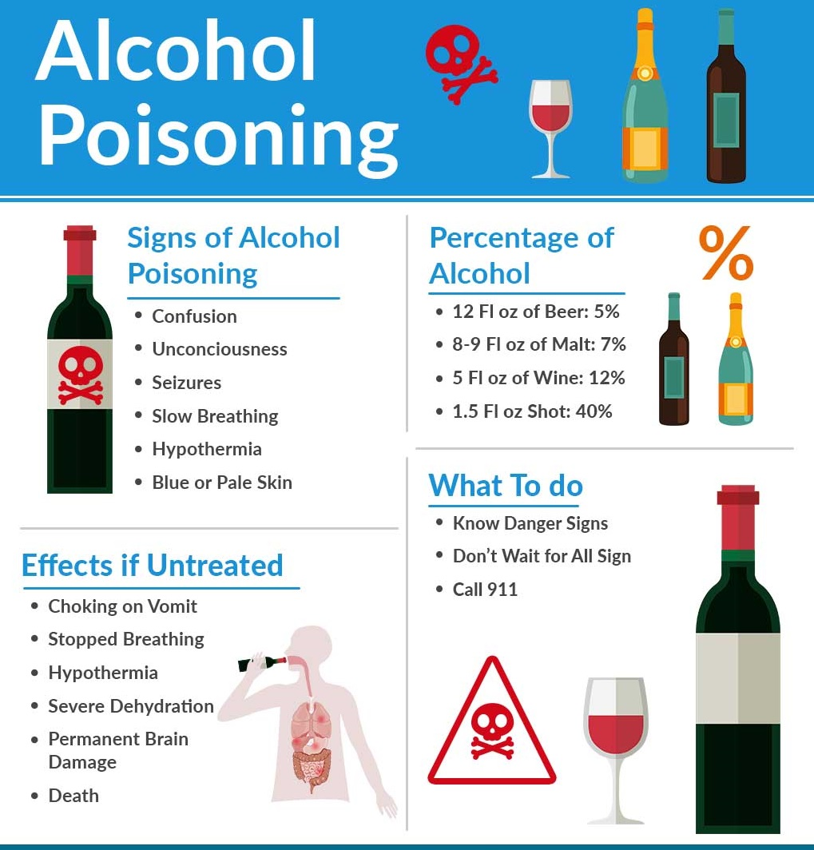
Underage drinking statistics in the USA
In 2015, 7.7 million young people ages 12–20 reported that they drank alcohol beyond “just a few sips” in the past month.

Based on data from 2006–2010, the Centres for Disease Control and Prevention (CDC) estimates that, on average, alcohol is a factor in the deaths of 4,358 young people under age 21 each year.
This includes:
1,580 deaths from motor vehicle crashes
1,269 from homicides
245 from alcohol poisoning, falls, burns, and drowning
492 from suicides

A link to this report below.
https://www.niaaa.nih.gov/publications/brochures-and-fact-sheets/underage-drinking
This is getting grim, but let's keep going there is a reason behind this and I will get to my main point soon.
NB.
2,712,630 people died in the USA during 2015 according to the CDC.
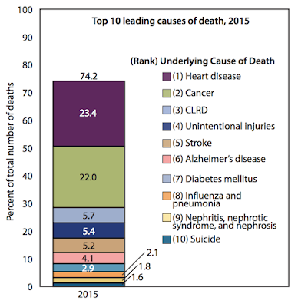
A link to this article is below.
https://fia.umd.edu/answer-how-many-people-die-each-year-in-the-us/
Now let us get to the heart of the matter.
Alcohol-impaired driving accounts for more than 30 percent of all driving fatalities each year.

More than 15 million people struggle with an alcohol use disorder in the United States, but less than eight percent of those receive treatment.

More than 65 million Americans report binge drinking in the past month, which is more than 40 percent of the total of current alcohol users.

Alcoholism affects people from all walks of life. According to the United States Centers for Disease Control (CDC), more than 88,000 people die from alcohol-related deaths each year in the United States.
a link to the source report is below.
https://talbottcampus.com/alcoholism-statistics/
More than 88,000 people per year die in the USA due to alcohol consumption, that is 247 people per day, as well as untold numbers that have non fatal injuries, rapes and a multitude of other violent and non violent crimes which are also influenced or in direct relation to drinking alcohol.
So what is the official story as to the effect that alcohol actually has on a human being?

Role of acute alcohol poisoning and craniocerebral trauma in the mechanism of death caused by subarachnoid haemorrhage

Result: The acute alcohol toxicity resulted in the swelling of brain tissues.

Conclusion: The alcohol has acute toxicity to brain cells.

A link to this report below.
http://europepmc.org/abstract/med/25735065

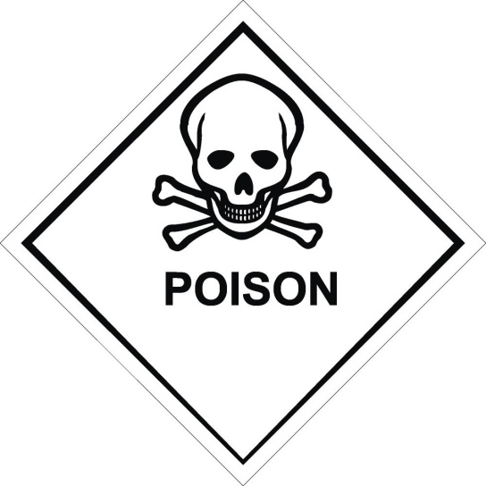

NB.
A number of disease conditions are wholly attributable to alcohol. These include alcoholic psychoses, alcohol-dependence syndrome, as well as some diseases affecting the nerves (alcoholic polyneuropathy), the heart (alcoholic cardiomyopathy), the stomach (alcoholic gastritis), and the liver (alcoholic liver cirrhosis).
The point - Alcohol causes psychoses!

So why does alcohol continue to be sold to the masses and why has it never been banned? It clearly is causing absolute pandemonium in this realm and is officially a poison.
Well actually there was a time in the USA that alcohol was indeed banned in a time of prohibition.
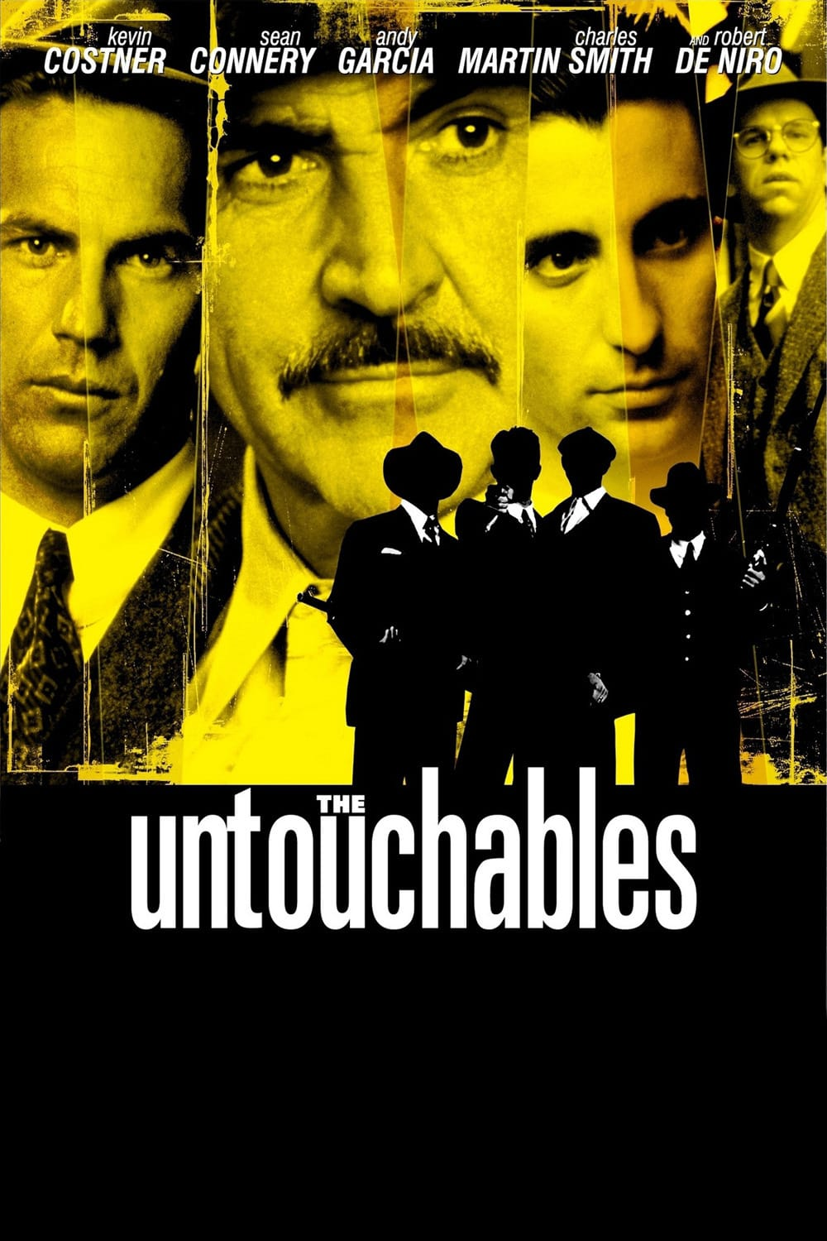
Brian De Palma, 1987

https://en.wikipedia.org/wiki/The_Untouchables_(film)

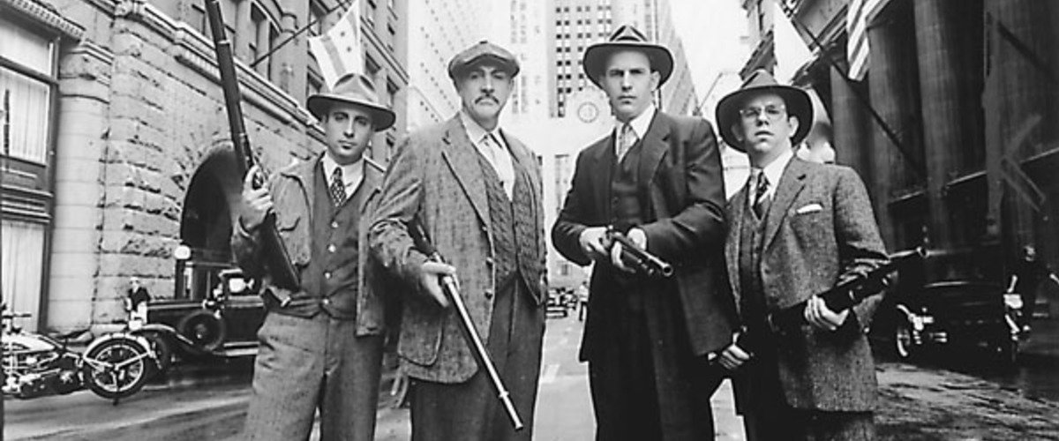
Part Two - Prohibition

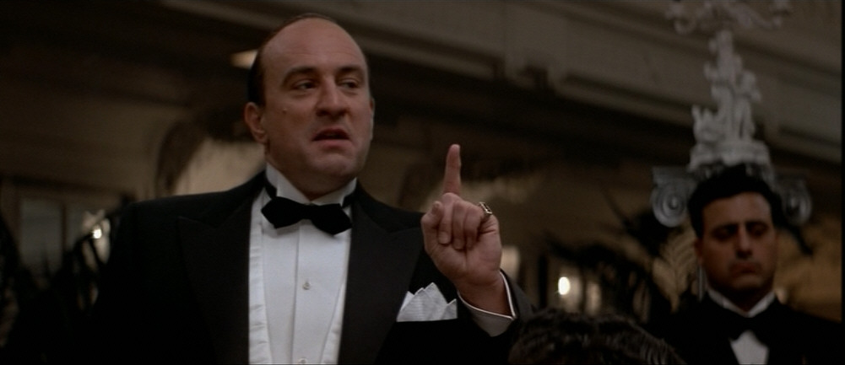
Al Capone (De Niro) in The Untouchables

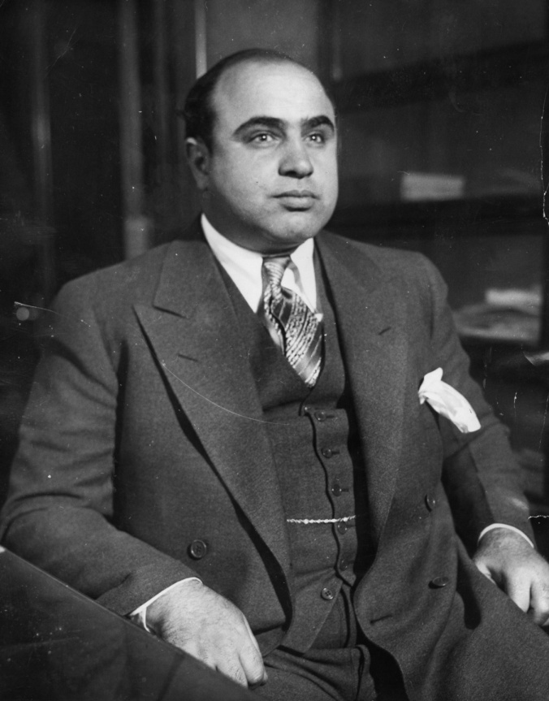
Alponse Gabriel Capone
Born - January 17th 1899 in NY
Died - January 25th 1947 (Aged 48) in Florida

Al Capone the infamous crime boss of Chicago, what was his main crime? Smuggling alcohol, with a little racketeering and murder to boot.
Being in the ACT scene for a while now I had heard the story that prohibition had actually taken place due to the oil companies forcing the ban on alcohol to give dominance to the petrol engine. There had been many cars prior to the 1920's that ran on alcohol, this could be partly true, however I am also aware that there used to be electric cars back at the beginning of the automotive industry. But the official story makes perfect sense to me when looked in the context of this article. Prohibition which ran from 1920 to 1933 as the official narrative goes is that during the nineteenth century, alcoholism, family violence, and saloon-based political corruption prompted prohibitionists, led by pietistic Protestants, to end the alcoholic beverage trade to cure the ill society and weaken the political opposition, this is captured well on Wikipedia and can be found at the link below.
https://en.wikipedia.org/wiki/Prohibition_in_the_United_States

The history of electric vehicles can be found here.
https://www.thoughtco.com/history-of-electric-vehicles-1991603

Interesting facts about fuel produced from alcohol which supports the story I had heard about the oil barons driving out this type of vehicle through prohibition.
Timeline of alcohol fuel - Wikipedia

They were already trying in 1862 to drive out this type of fuel.

"In 1862 and 1864, a tax on alcohol was passed in the U.S. to pay for the Civil War, increasing the price of ethanol to over $2.00 per gallon. A new product from petroleum, called kerosene, is taxed at 10 cents a gallon."

"In 1906, the Free Alcohol bill is passed. The USA repeals the alcohol tax under Teddy Roosevelt. At 14 cents per US gallon, corn ethanol was cheaper than gasoline at 22 cents per US gallon."

"In 1914, the Free Alcohol bill is amended again to decrease the regulatory burden and encourage alcohol fuel production in the U.S."

In 1917 Alexander Graham Bell says: "Alcohol makes a beautiful, clean and efficient fuel… Alcohol can be manufactured from corn stalks, and in fact from almost any vegetable matter capable of fermentation… We need never fear the exhaustion of our present fuel supplies so long as we can produce an annual crop of alcohol to any extent desired."
Part Three - What is Schizophrenia?
The information below is taken from the NHS (National Health Service) official website in the UK.
Schizophrenia is a severe long-term mental health condition. It causes a range of different psychological symptoms.
Doctors often describe schizophrenia as a type of psychosis. This means the person may not always be able to distinguish their own thoughts and ideas from reality.
Symptoms of schizophrenia include:
- hallucinations – hearing or seeing things that don't exist
- delusions – unusual beliefs not based on reality
- muddled thoughts based on hallucinations or delusions
- changes in behaviour
Some people think schizophrenia causes a "split personality" or violent behaviour. This is not true.
The cause of any violent behaviour is usually drug or alcohol misuse.
(NB. See my testimony in part eight, I can tell you that the above statement about violence and split personality is not true, this is not the case at all)
A link to the site as below.
https://www.nhs.uk/conditions/Schizophrenia/
Below is a link to another page on the same site giving information on hallucinations, one of the main symptoms of schizophrenia.
https://www.nhs.uk/conditions/hallucinations/
I have pulled out the key points below. Hallucinations and hearing voices
Hallucinations are where someone sees, hears, smells, tastes or feels things that don't exist outside their mind.
They're common in people with schizophrenia, and are usually experienced as hearing voices.
Hallucinations can be frightening, but there's usually an identifiable cause. For example, they can occur as a result of:
- taking illegal drugs or alcohol
- a mental illness, such as schizophrenia
- a progressive neurological condition, such as Alzheimer's disease or Parkinson's disease
- loss of vision caused by a condition such as macular degeneration – this is known as Charles Bonnet syndrome
See your GP straight away if you're experiencing hallucinations. The recommended treatment options for hallucinations will depend on the underlying cause. For example, antipsychotic medication may help with hallucinations for people living with schizophrenia.
Scary stuff and would you believe that the so called experts in this field openly admit that they do not know what causes schizophrenia, they really do not have a clue. They have identified certain triggers that aggravate the situation such as stress or drug and alcohol abuse but that is it. Antipsychotic medication is always the preferred treatment. This essentially in most cases retards thinking in people by reducing what has been identified as dopamine in the brain. Slowing them down to a point where even everyday tasks such as getting dressed or washing are extremely difficult. Of course the medications are exceedingly expensive and have a litany of other nasty side effects.
A link below to some basic information on dopamine.
https://www.psychologytoday.com/us/basics/dopamine

A link below to information on the antipsychotic drugs used to treat schizophrenia.
https://patient.info/mental-health/schizophrenia-leaflet/antipsychotic-medicines
There is one commonality between all the antipsychotic medications, dosage has to be increased if the patient drinks alcohol on a regular basis. The effectiveness of the drugs is diminished. There are strangely enough two other substances that have the same effect, one is coffee and the other is tobacco.
1% of the population has schizophrenia?
Part Four - Demonic Possession
To anyone in the ACT scene the mainstream media, its movies, books and TV programs all blatantly show components of the agenda's at play in this realm. Do you think that demonic possession would be any different? Do you believe it to be just a fantasy story to pump fear into you during a two hour movie, eliciting emotional responses purely for entertainment (Go into and take hold of your mind)?
Examples in the media are many, but for most, this topic can be summed up all in one movie in particular.
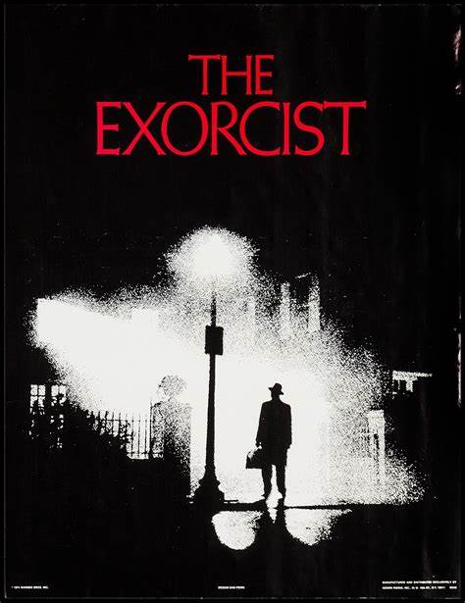
William Friedkin - 1973

From the British newspaper, The Telegraph.
Valter Cascioli, a psychologist and scientific consultant to the International Association of Exorcists, which is endorsed by the Vatican, described as an “emergency” the lack of priests capable of fighting the forces of evil. “The lack of exorcists is a real emergency."
https://www.telegraph.co.uk/news/2016/09/26/urgent-need-for-more-exorcists-as-increasing-number-of-people-da/

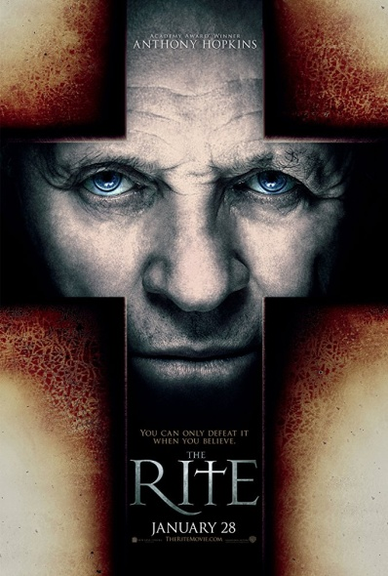
The Rite - Mikael Håfström (2011)
An American seminary student travels to Italy to take an exorcism course.
https://www.imdb.com/title/tt1161864/

From the British newspaper, The Telegraph
A week-long exorcism conference, held this week at the Pontifical University of Regina Apostolorum in Rome and endorsed by the Vatican, is being attended by around 160 Catholic priests from around the world, who insist that demonic possession is very real.
https://www.telegraph.co.uk/news/worldnews/europe/italy/11533635/Pope-Francis-effect-leads-to-exorcism-boom.html

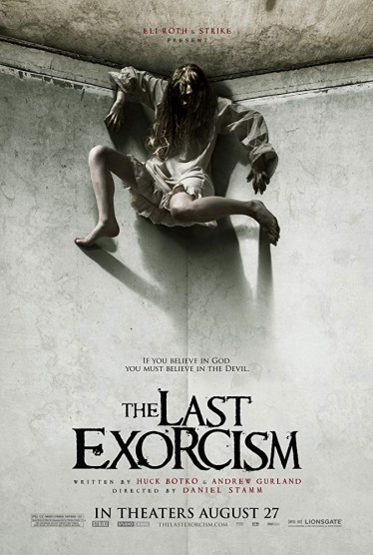
The Last Exorcism - Daniel Stamm (2010)
A troubled evangelical minister agrees to let his last exorcism be filmed by a documentary crew.
https://www.imdb.com/title/tt1320244/
Did you witness demonic possession? A response time analysis of the relationship between event plausibility and autobiographical beliefs

A very interesting study proving that normies will not look for evidence of an event if the event does not seem plausible to them, even more interesting for this article was the subject matter used.
A link to the study below.
https://link.springer.com/content/pdf/10.3758%2FBF03194064.pdf

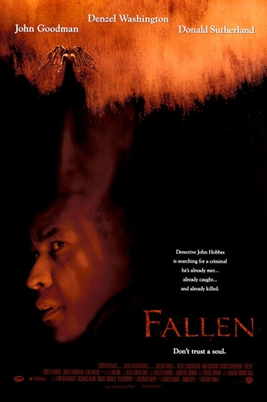
Fallen - Gregory Hoblit (1998)
Homicide detective John Hobbes witnesses the execution of serial killer Edgar Reese. Soon after the execution the killings start again, and they are very similar to Reese's style.
https://www.imdb.com/title/tt0119099/

When a model becomes the real thing: A neuro-cognitive account of ‘demonic’ possession
Department of Ethology, Eötvös Loránd University, Pázmány Péter sétány 1/c, 1117 Budapest, Hungary

https://www.sciencedirect.com/science/article/pii/S0306987717301111?via%3Dihub

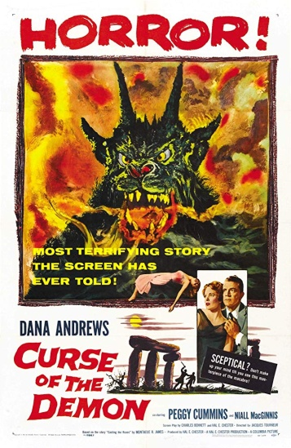
Night Of The Demon (UK) - Jacques Tourneur (1957)
American professor John Holden arrives in London for a parapsychology conference, only to find himself investigating the mysterious actions of Devil-worshiper Julian Karswell
https://www.imdb.com/title/tt0050766/

The Growing Evidence for Demonic Possession: What Should Psychiatry’s Response be?
- Stafford Betty

Evidence of evil spirits is voluminous and comes from many cultures, both ancient and modern. Cases from China, India, and the United States are examined and evaluated. The actual experience of spirit victims, the universality of spirit oppression, the superhuman phenomena associated with “possession,” and the comparative success of deliverance and exorcism vs. psychiatry are considered. Potential arguments against the spirit hypothesis centre on the antecedent improbability of spirits, multiple personality disorder, and the effectiveness of medication; but these can be countered. Psychiatrists should question their materialist assumption that mental illness is strictly a matter of an aberrant brain, carefully examine the literature of possession, experiment to determine why exorcists and deliverance ministers often succeed where psychiatry fails, and develop a more complete inventory of techniques for healing the complete person.

https://link.springer.com/article/10.1007/s10943-004-1142-9

Part Five - What Is Going On Here?
Another real world example of exorcism.

Real-life exorcists: new film sheds light on increasing demand for curing demonic possession
https://inews.co.uk/inews-lifestyle/wellbeing/real-life-exorcists-new-film-sheds-light-increasing-demand-curing-demonic-posession/

The examples I have presented above are but a small handful of countless articles, books and studies that affirm that demonic possession is in fact a real thing, not an ignorant peasant belief from the past but an actual real world phenomenon.
It is yet another black pill to swallow, the normies in general hold to the main stream consensus that demonic possession is a fiction usually used in media such as movies as entertainment, this maybe the one critical thing that is stopping demonic possession from spreading like wild fire throughout the population. Belief is converted into will, will is powered by thought, thought affects the reality in which we exist.
I do not hold to the existence of a Christian God, neither do I believe that his son came to save us 2000 years ago. But the Catholic priests that perform these exorcisms through indoctrination hold an absolute iron clad belief in Jesus / Yeshua, this faith, this thought is what powers there will, giving them the ability to drive out invading entities from their human hosts.
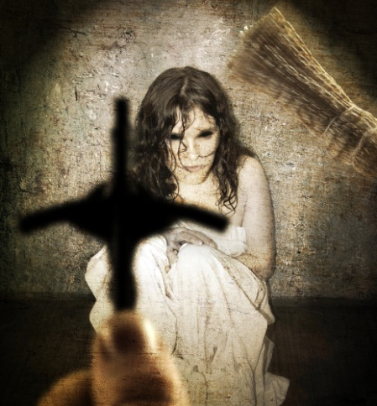
Belief is the enemy of knowing, Crrow777
Part Six - The Origin Of Alcohol
The manufacturing process of ethanol / alcohol
https://www.chemguide.co.uk/organicprops/alcohols/manufacture.html

The manufacture of synthetic ethanol
http://www.americanenergyindependence.com/syntheticalcohol.aspx

In 1975 Paolo Rovesti (1902–1983) a chemist and pharmacist who became known as ''father of Phytocosmetics'' discovered a terracotta distillation apparatus in the Indus valley in West Pakistan which dates from around 3000 BC, this is supposed to be the earliest known time when alcohol was produced.
(NB. Ancient history is a hoax}
https://en.wikipedia.org/wiki/Distillation
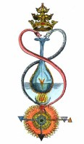
Alcohol is the only solvent which extracts the plant's chemicals at the same ratios contained in the plant. Alcohol is also strictly produced from plants themselves. It is a solvent made by plants for plants.
https://www.evolvedalchemy.com/what-is-spagyrics

Spagyrics (Alchemy)
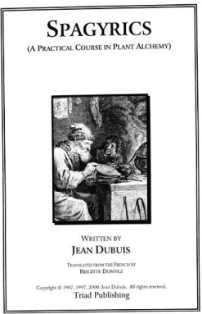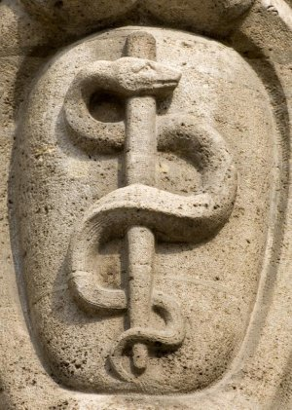

Alcoholic spirits - that means that the spirit of the plant has been removed, liberated from the prison of matter.

Alcohol is literally the life essence or soul of plants.
Part Seven - Another Piece Of The Puzzle, Not Just American Gods

The novel.
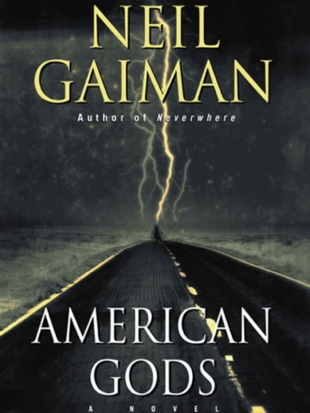

The comics
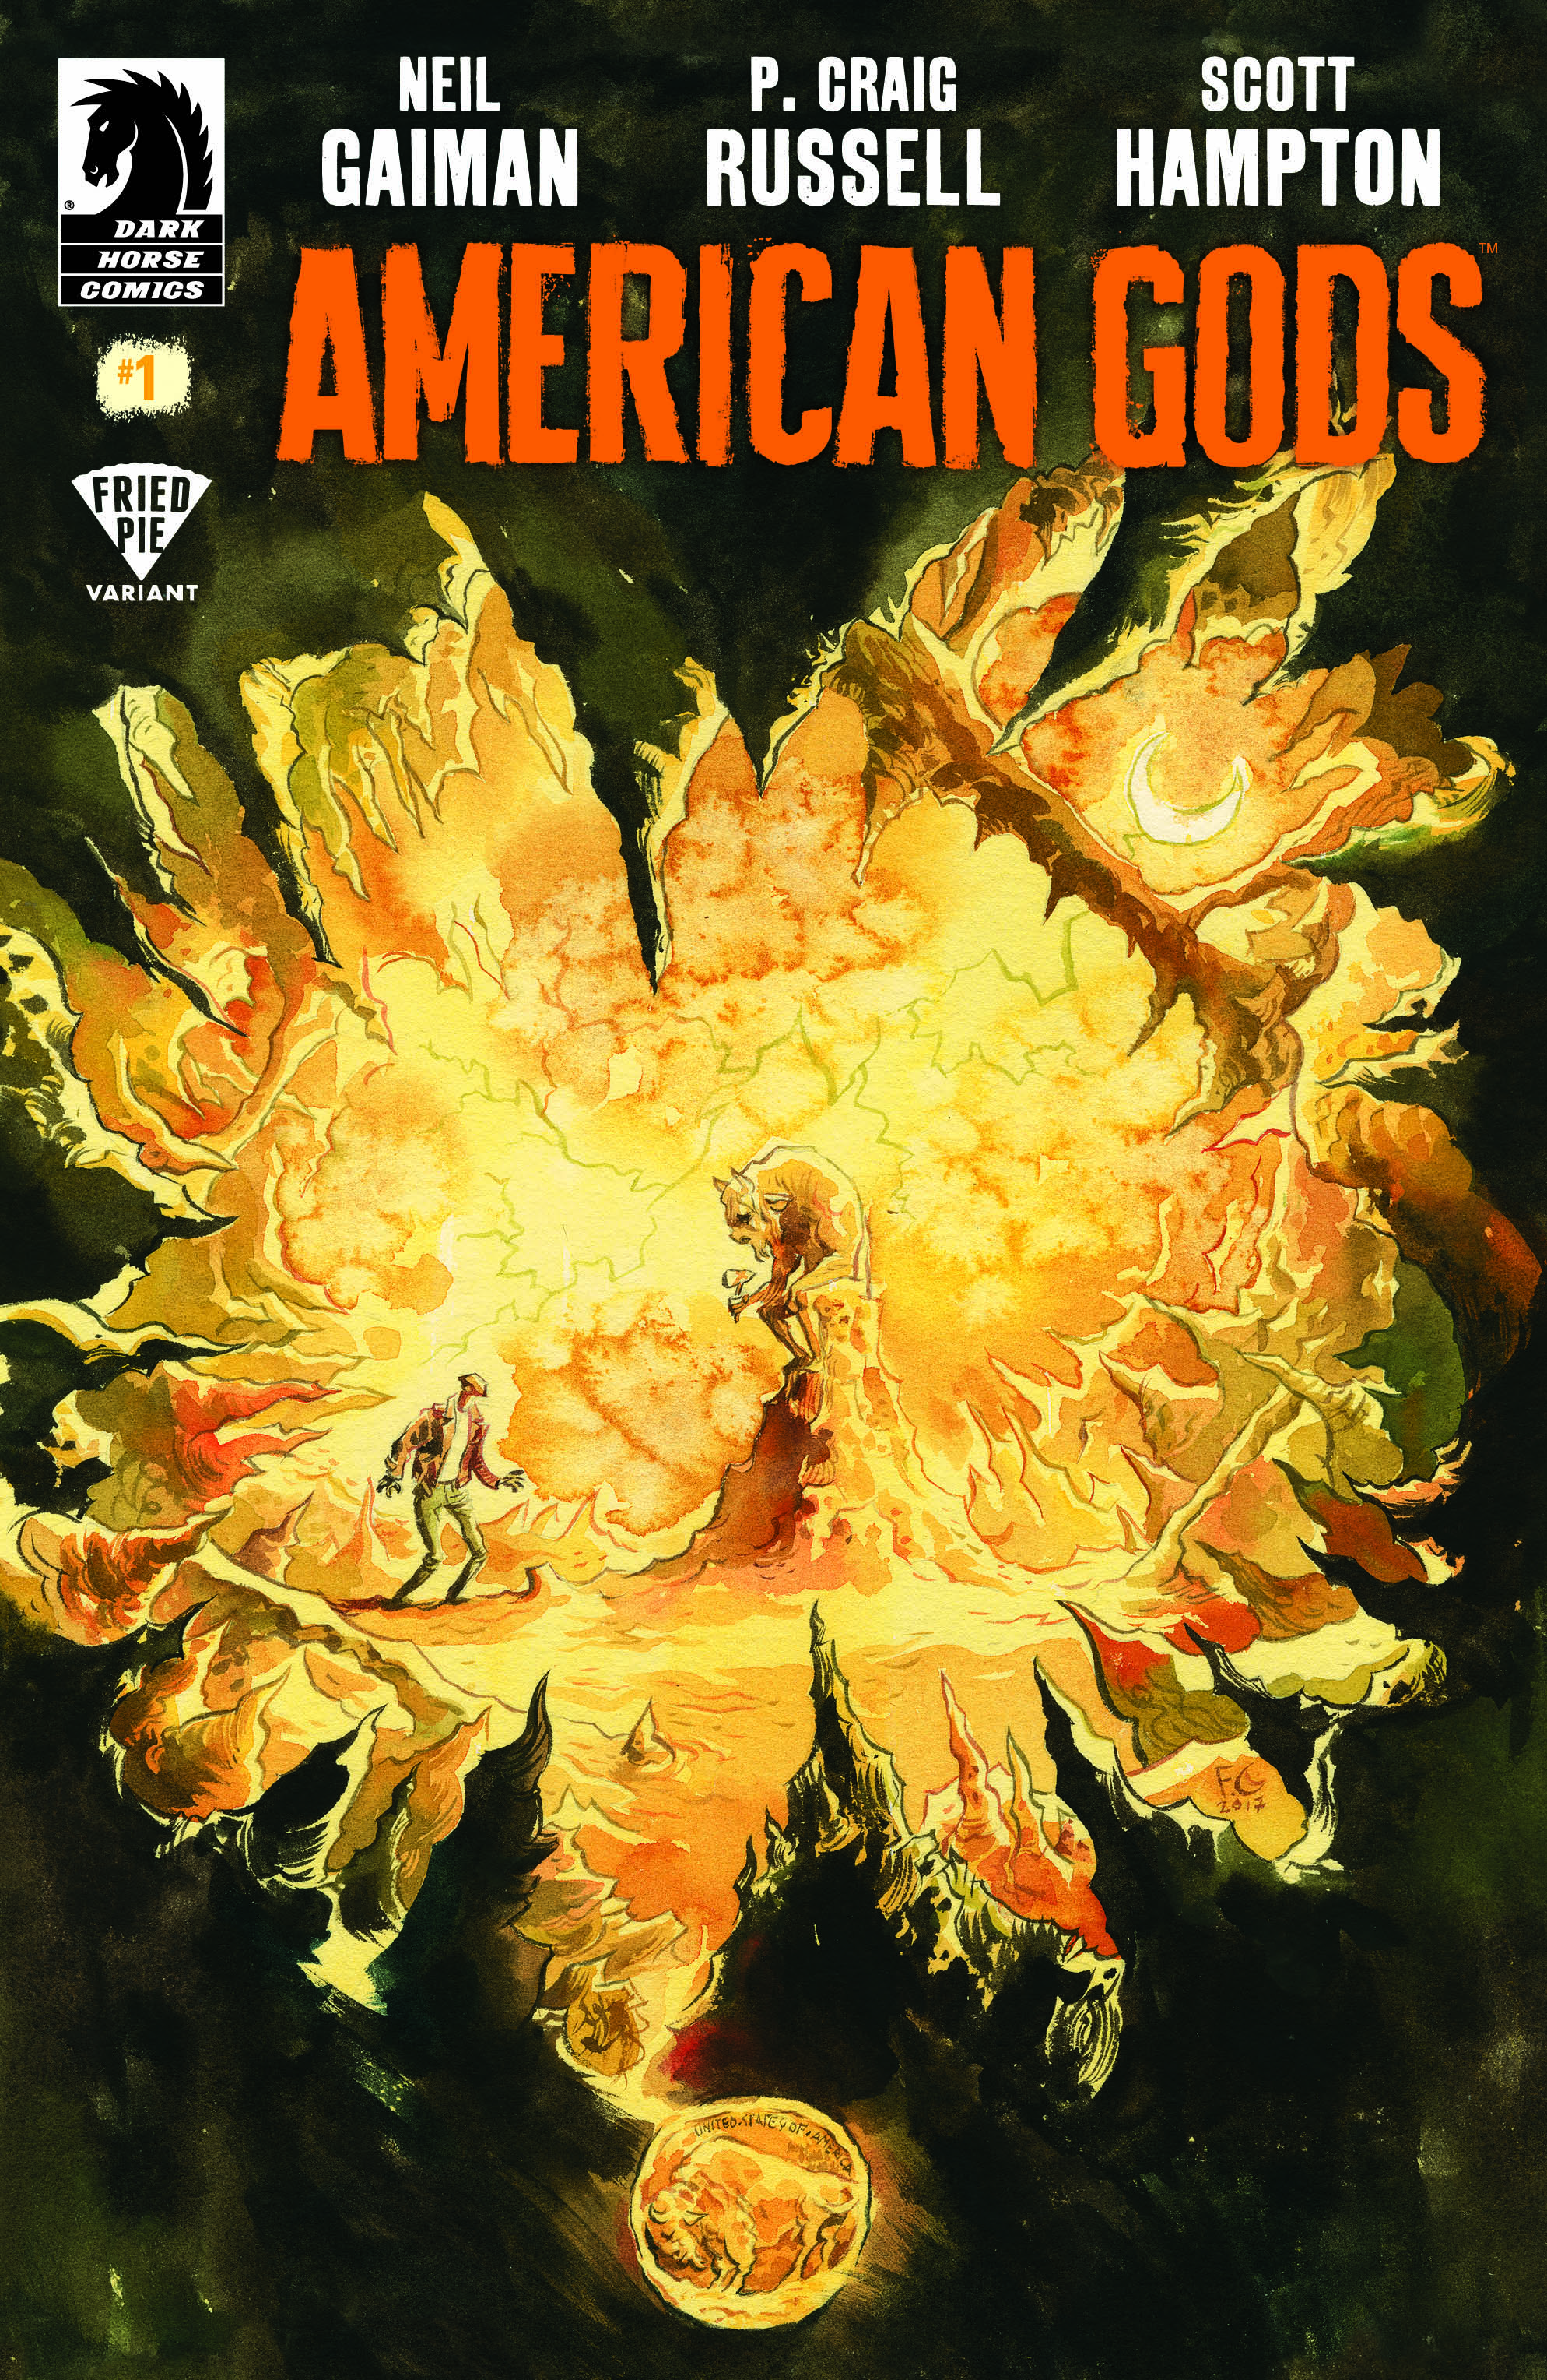

The TV series

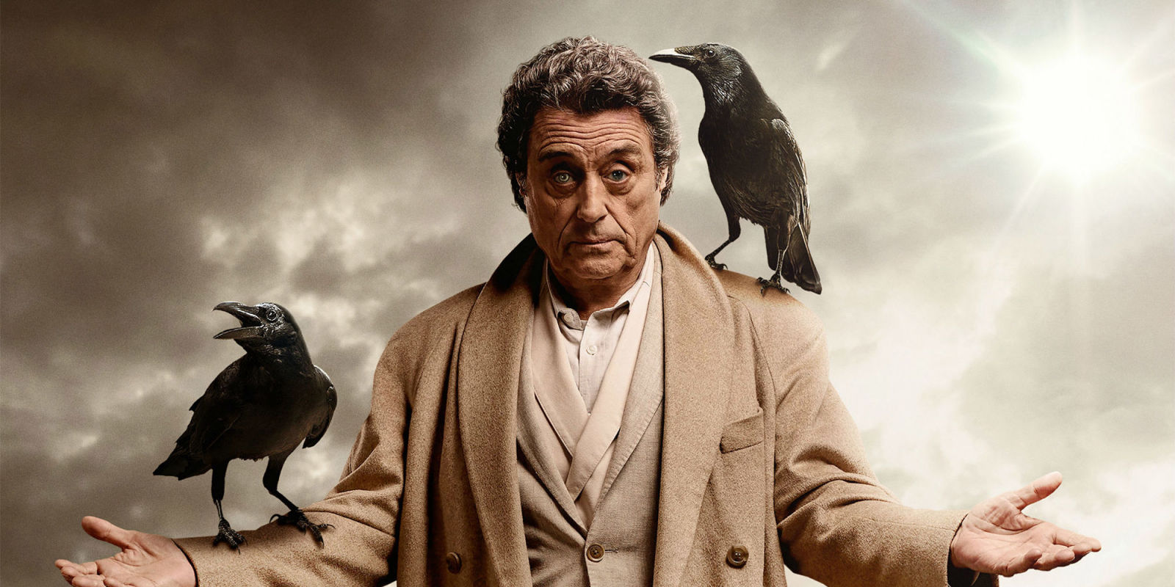
Ian McShane as Mr Wednesday, The All Father, Odin

A good synopsis of American Gods is on Wikipedia
https://en.wikipedia.org/wiki/American_Gods

So much can be said about "American Gods", the story the characters and the symbolism prolific in the both the written media and the TV series, so much to explore. It has to be said that the original book is an incredible piece of storytelling and the TV series does an amazing job of capturing the spirit of it.

For this article it is the main theme of "American Gods" that I want to put forward. The essence is that man invents stories of religion and then through belief the Gods manifest into reality.

This concept has so many implications, but to me and experiences throughout my life, I now suspect that the following statement encapsulates my take on the situation.

Man invents stories of religion, spiritual entities then assume the role of said deity.

What makes me say this? I have looked into the Norse religion, I am confident 100% that it is a hoax, the story was made up in 1795.

But my following testimony will give you a feeling for what I am postulating.

Part Eight - My Testimony

Twenty years ago my family went through a crisis, not the first and not the last but certainly the most profound. I have two younger brothers and they are twins but not identical. One of my brothers has walked a very dark path. It all started in his early teens. He was caught on a number of occasions causing a fracas in public after eating magic mushrooms.

That was just the start of his journey and he got in trouble so many times I cannot count, a combination of burning church doors, sacrificing cats and Ouija board sessions to name a few escapades.

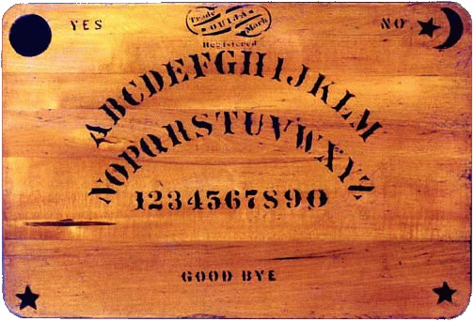

When my brother left school his activities and circle of friends over the coming years took on a new dimension altogether.
At eighteen years old my brother became involved in a church, I cannot remember the name but it was one of these separate to the normal Church of England congregations. It was essentially a brain washing cult, the church would pack members into rented houses twelve or more at a time where they would all jointly pay the rent on the property, but be required to donate most of the money they earned to the church. Many times I received phone calls from my brother asking me to help him as he had no food to eat.

It was also around that time that my Mother passed away long before her time at the age of forty eight, after an automobile accident which led to her having a brain tumour, when finally discovered was too late to operate on.
I really believe that my Mothers passing was one of the main spring boards that led to my brother leaving his church and escaping the brain washing, but where he went to next was the start of a slippery slope and it would have been better for him and everybody if he had carried on promoting Jesus.

Over the next ten years I rarely saw my brother as he moved to my Uncles in Blackpool in the northwest of England. He worked as a barman, a croupier and a road sweeper in his normie job. But in his spare time, first he practiced Voodoo then as part of a group moved onto Odin worship or in his case Tyr.

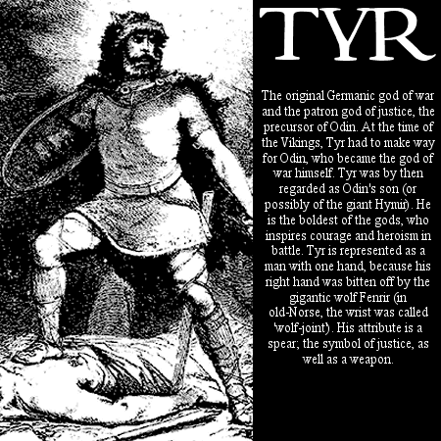
My brother visited or moved back to the Midlands for short periods of time. It was on one of these time periods back home that he met his future wife, a lovely blonde lady from Finland.

It had been almost five years since the death of my Mother and my brother leaving the church, at the time I suspected nothing, in fact any interactions I had with my brother were always usually fun. My brother was always the joker of the family, from a young age he was the loud annoying one. He then moved to Finland and got married, it was then that I started receiving phone calls in the middle of the night. The first time I received one of these late night calls was distressing to say the least. My brother would be screaming that demons were trying to get him, that he saw demons and other entities, they were pacing around outside and trying to get in through the windows. Not only did he phone me in desperation but other times just to talk. He would tell me about what he had being doing with the Norse group in Blackpool and some of what he told me chilled me to the bone.

In a nut shell this Norse group truly believed that the Viking pantheon of Gods was a real thing. They discussed them, they worshipped them and they summoned them. The members of this group individually swore an oath to one of the Gods swearing to be their servant for the rest of their life. My brother described rituals that they would perform that ultimately would allow the Gods to use their bodies as vessels to allow communication and instruction.

My brother told me about the first ritual that he had attended where the self professed leader of this group summoned the spirit of the All Father, Odin into his body. He described the ominous feeling of presence and change of atmosphere as Odin entered the host, the change in voice to a booming authorative tone and that the spirit was so intense so powerful that the energy of this summoned spirit leaked out of the eyes of the more than willing participant in glowing tendrils of light.
Over the space of a few months my brothers hallucinations escalated, he was living in constant fear. He made the decision to approach a mental health hospital in Finland where he was admitted and treated, I never found out what he was given to quell the hallucinations at the time but assume it was some kind of antipsychotic drug . All went quiet and things seemed to have settled down, then out the blue my brother declared that he and his wife were returning to the UK as the job situation in Finland was rather bleak for both of them.
It was after about twelve months of the return to England that my brothers behaviour was noticeably different. He and his wife had rented a ground floor flat not far from Birmingham City centre on a busy main road. My brother had started to appear nervous when I met up with him occasionally at weekends, not with me but just his general mood. He did not mention at the time that he had started seeing things again. It was then that he started disappearing for unexplained hours, he told the family that he was going for walks. He also did not mention at the time that he was concerned and had approached a mental health hospital here in the UK for assistance, but unlike the facility in Finland this one turned him away.
What follows now is dark, gruesome and horrifying and I warn you that disturbing revelations will come from what I am about to tell you, where it leads may not be something you even want sitting in your mind. But for those that really want to know yet another truth of what is going on here in this realm, then I offer you a key to the door.
My brothers disappearances intensified until one day instead of a few hours he went missing for two days. His wife was out of her mind with worry and myself and my brothers twin were tasked with looking for him, we searched but to no avail.
It was the Police that brought him back home, he was found wandering in a park miles from his home, dishevelled, dirty and zombie like.
The next day my brother's wife had left early in the morning to go to work leaving my brother on his own in the flat. As I mentioned earlier this was a ground floor flat but this was not self contained. The flat was in a large old house where rooms were converted into flats throughout. Upstairs one of the flats was rented by a homosexual young man, I had actually bumped into him a few times, he was harmless and did not deserve what was about to happen to him, nobody deserves the horror that this poor guy was about to receive.
Sometime in the early afternoon my brother went up the stairs to this young man's flat, kicked the door in and proceeded to put his victim through at least two hours of horrendous torture. This culminated in this young man being hung by the neck on a rope, stabbed fifteen times with a carving knife and horrifically my brother scooped his one eye out with a metal spoon. I do not know how close it had come, but the young man survived this experience albeit scarred for life. If it was not for the intervention of the Police who had been alerted to the scene by screaming that the young man most definitely would not have lived another day.
The story only gets stranger from here on in. Four Police officers arrived at the scene, when they got upstairs they caught my brother with the knife in his hand stabbing the young man. They proceeded to tackle my brother, they will probably have nightmares for the remainder of their lives with what they faced that day. It is a good thing my brother discarded the knife when the Police went for him as they probably would all be dead. My brother screamed out that he was the, "Blood God" and he proceeded to take hold of the policemen and throw them around like rag dolls, lifting them above his head as though they were feather weight. They did not have a chance but one of them managed to call for back up. It took twelve police officers in total to bring down and restrain my brother that day. They remarked that it was like having to fend off Superman.
Myself and the twin had been alerted by my brother's wife of the incident and the twin was outside the flat when my brother was man handled and thrown into the back of a van. He was covered in blood from head to toe, the twin was concerned and thought that the Police may have harmed my brother, but the Policemen calmed the twin and told him that not one drop of the blood on my brother was his own. My brother was taken into custody and after processing was put straight into Prison, it was around six months before he was to be trialled.
The Judges verdict was insanity, my brother was sent to a high security mental asylum (no other word describes it) he was diagnosed with schizophrenia. I never visited my brother while he was in prison, neither did his wife, in fact we never saw her again she went back to Finland that week and filed for divorce.
When my brother was moved to the mental facility I made regular visits to go and see him. We were allowed to meet him in a common room initially for our safety with many staff at hand. The first time I visited him was terrifying. He was obviously drugged up with masses of antipsychotic medication. But let me tell you, this was not my brother sitting before me, his face was contorted, he did not utter a single word his eyes were devoid of humanity. There was an over whelming presence of something else, something not human.
Slowly over the course of around three months the presence diminished and my brother started communicating again. He was distraught, he suffered then and he still struggles now twenty years later with the horror of what he did to that young man.
My brother stayed in two mental institutions for seven years, he was then released into the community under a section maintained by the British Home Secretary under continual monitoring and medication.

Last year I sat in a court room with my brother and he was made a free man by a judge. To this day I am well aware that the thing my brother had let invade his mind had not been exorcised from him. Every now and then I feel it watching. This is why I went for medium training some years ago and believe me I have so much more to share. But for now, know this, there are powers at work in this world and they are certainly dark as hell.

Fin

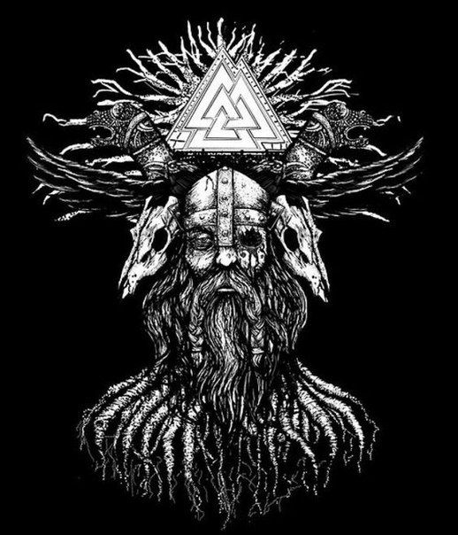
Part Nine - "9"
The underworld is signified by the number "42"
4+2 = 6, 6 is the mirror of "9" reflecting the real world

William Friedkin = 1152 in Jewish Gematria, this reduces to "9"
William Friedkin = 155 in Simple Gematria, this reduces to "11"
"9/11"
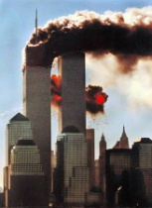

The Shining movie released in 1980
1+9+8 = 18 which reduces to "9"

Based on the 1977 book by Stephen King
1+9+7+7 = 33 which reduces to 6, 6 is the mirror of "9"

Brian De Palma directed The Untouchables, premiered June 2nd 1987
Brian De Palma in English Gematria = 576, 5+7+6 = 18 which reduces to "9"
June 2nd 1987 = 6+2+1+9+8+7 = 33, which reduces to 6, 6 is the mirror of "9"

Alponse Gabriel Capone
Born January 17th 1899 in NY
January 17th 1899 (999999)
1+1+7 +1+8+9+9 = 54 which reduces to "9"

Died - January 25th 1947
1+2+5+1+9+4+7 = 29 which reduces to 11

"9"/11

What a pick to play Odin in American Gods.
Ian McShane Born: 29 Sep 1942 (current age 76)
2+9 = 11 and September is "9"
"9"/11
Ian McShane in English Gematria = 522
5+2+2 = "9"

Odin in English Gematria = 252
2+5+2 = "9"

Ian McShane in Simple Gematria = 87
8+7 = 15 which reduces to 6, 6 is the mirror of "9"

Odin in Simple Gematria = 42 (The Underworld)
4+2 = 6, 6 is the mirror of "9" (Reflection of the real world)

Part Ten - They Tell You In The Movies


The Entity - Sidney J. Furie (1982)
A woman is tormented and sexually molested by an invisible demon.
Based on a true story.
https://www.imdb.com/title/tt0082334/


The Evil Dead - Sam Raimi (1981) / Evil Dead - Fede Alvarez (2013)
Demons are summoned and take hosts one after another.
https://www.imdb.com/title/tt0083907/
https://www.imdb.com/title/tt1288558/


The Spirit - Frank Miller (2008)
A rookie cop returns from the dead as The Spirit
https://www.imdb.com/title/tt0831887/

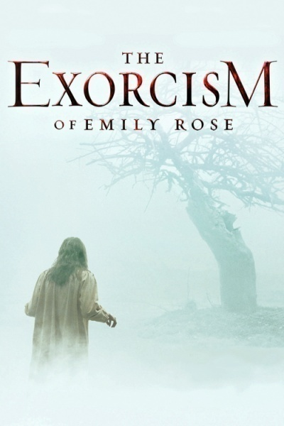
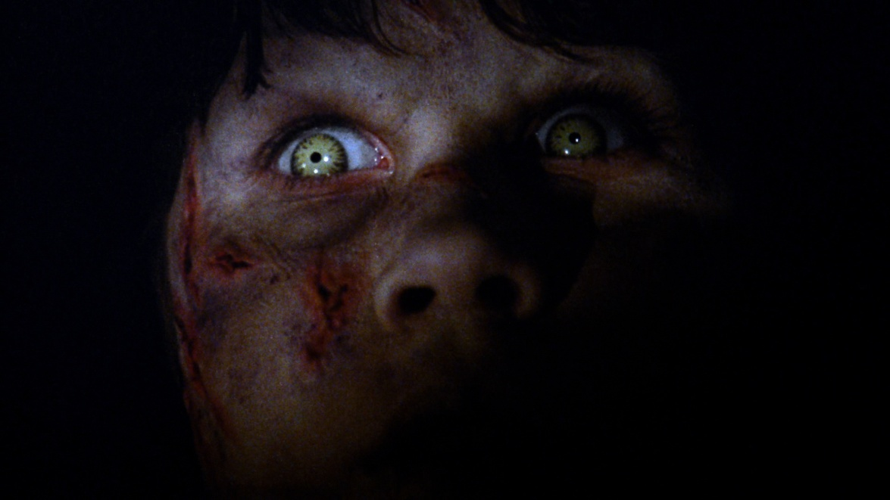
Part Eleven - Grounding & The Power Of A Soul
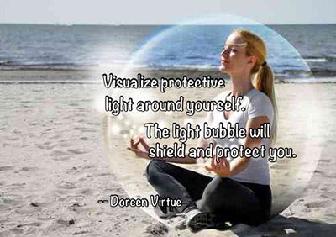

Protecting yourself.
https://www.mojan.com/content/spiritual-grounding-centering-clearing-protection

https://www.spiritearthmag.org/2018/08/16/grounding-protection/

http://www.rescuemediums.com/grounding-and-protection.php

The human soul is powerful beyond belief, you are a creator.

Your thoughts directly impact the nature of your reality.

The human will is the most potent thing in reality.

The will combined with the word is how magick is worked.

The will combined with visualisation is the surest way to create the reality you desire.
tl;dr

The information I have presented here has haunted me for the last twenty years. We have a substance, alcohol that is physically damaging to the human body, a poison. This addictive poison appears to be the living essence the spirit energy or soul of a plant. This essence is also synthesised in a twisted opposition to nature. Alcohol I am convinced opens a gateway in our minds for entities to gain access. Other addictive substances such as tobacco and coffee have the same effect. These products are demonised in the media yet are still allowed to proliferate, this is no accident. Neither is it an accident that the word demon is used as a descriptor in our culture along with the word "spirit".
It is obvious that whether rich or poor, young or old, all are consuming alcohol to some degree. No corner of authority in our civilisation is immune to this pervasive substance. There was even a point in history where alcohol was banned and again I think this no coincidence.
I personally have no fear consuming alcohol, I do not drink much anyway, I also do not fear to consume tobacco or coffee. I protect myself in a similar process taught to me as described in part eleven. I go through this procedure at least once a month and if I am feeling negative influences I do it again to dispel them.
I included the study on implausibility because it encapsulates the idea so well that humanity has been programmed with a set of belief systems many of which are in opposition to each other (this again I think is no accident) and why so many beliefs are patently false. That people will dismiss on a whim any thought because on the surface it is implausible. This is another manipulation of humanity and the ego.
It is generally through personal experience that someone will throw away the programming, after witnessing something so profound with their own eyes it is then the illusion crumbles.
This reality is so unlike what we are taught, yet we can logically and systematically break down each component of deception, that much is now clear.
TPWRTH could certainly be guided by entities wanting to own the very spirit of humanity, they are inferred to be the "Nine". We live in the time of apocalypse all is being revealed, the programming is falling apart before our very eyes.

We are part of a spiritual battle



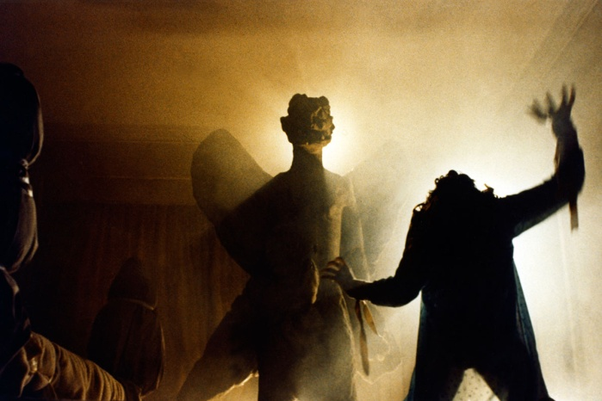

Addendum

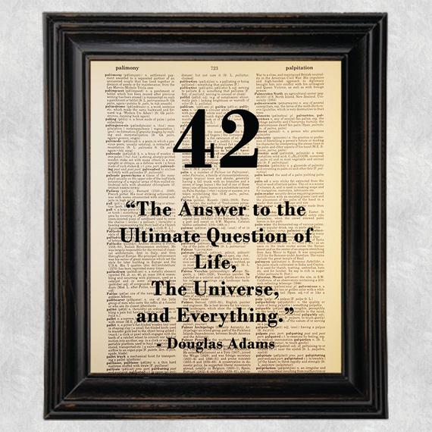

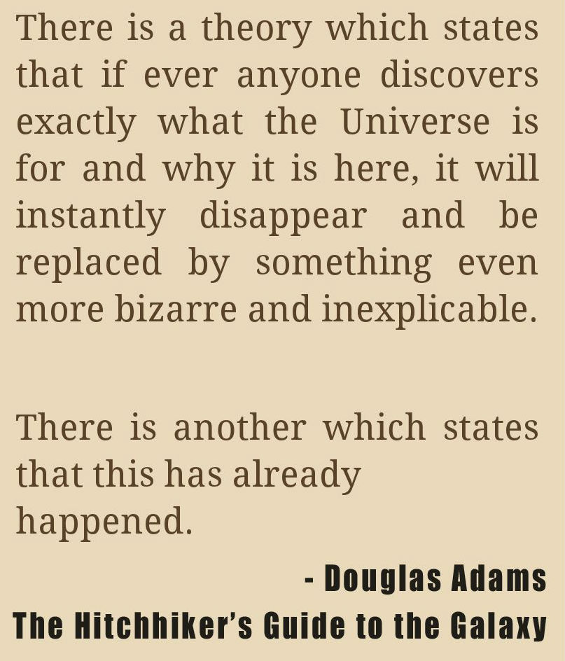

They want your pity, to open your heart to them. In the end, they want your soul.
This is an all out war. They want to take you down with them into darkness and separate you from God at all costs, after all "They" have nothing to lose.
If you do not understand that we are the prize being fought over in this war, then you have much larger problems than I can help you with.
Rebecca [Occult Specialist of S.I.S.]
7/2010
Demons are the disembodied spirits that come from the death of the hybrid offspring of the Fallen. Due to the unnatural origins of the Nephilim/Rephaim /Emims/Anakim [born of the sons of God with human women - Gen 6:1-6] When they die there is nowhere for their spirits to go, since they were not created naturally by the Creator there is no natural place for them. This is why they so strongly desire to dwell within us or possess us, because they once had a body of their own. They do not possess what would be considered a spirit body as an angel does, all they knew was a physical body, so it's torment for them to be without a meat suit.
Rebecca {Occult Specialist of S.I.S.}
December, 2012

The possessive states disorder: The diagnosis of demonic possession
https://link.springer.com/article/10.1007/BF01760734

Beyond Simulation: An Enquiry Concerning Demonic Possession
https://link.springer.com/chapter/10.1057/9781137447494_9

Projection, Double Bind, and Demonic Possession: Some Common Elements in Three Theories of Psychosis
- Gerald H. Zuk
- Carmen V. Zuk
https://link.springer.com/article/10.1023/A%3A1025032432562


Me, TNG after 5G?

